Activity 1.3.2 Can You Hear Me Now?
Introduction
In the last activity, you learned what can go wrong in the ear to cause different types of hearing loss. Hearing tests are the first step toward understanding hearing loss. There are several different hearing tests that can be done to determine the type and extent of one’s hearing loss. Once the hearing loss has been determined, the most appropriate intervention(s) can be identified to help the person regain as much normal function as possible. In this activity you will perform a variety of different hearing tests. You will then explore the various interventions available to help patients cope with hearing loss and make a recommendation as to what intervention is the most appropriate for your hearing loss patient from the previous activity.
Equipment
- Computer with Internet access and Logger Pro Software
- Activity 1.3.1: Student Resource Sheet
- Activity 1.3.2: Student Resource Sheet
- 512 Hz tuning fork
- Stop watch (or timer on phone)
- Headphones with disposable ear pads
- Cotton balls
- Laboratory journal
- Career journal
Procedure
Part I: Hearing Assessment
Please note that the hearing assessments used in this activity are not meant to be diagnostic tools to detect hearing loss. Hearing should only be tested by qualified professionals.
Rinne Test
- Obtain a 512 Hz tuning fork and a stop watch (or timer on phone).
- Go to the following website. Click on View QuickTime Movie to watch a short video of someone performing the Rinne Test of a subject. Note that the video may take a few minutes to load.
- Webster University – The Rinne Test http://www.webster.edu/~davittdc/ear/rinne/rinne.htm
- Work with a partner. Have one partner act as the subject and sit with his or her eyes closed. The other partner will act as the tester. The tester will complete Steps 4 – 9.
- Strike the tuning fork on your wrist or the sole of your shoe, causing it to vibrate.
- Place the end of the tuning fork’s handle against the subject’s mastoid process (the bone directly behind the bottom of the subject’s earlobe). Make sure that the prongs of the tuning fork are pointed downward and away from the ear. Begin timing with the stop watch.
- Ask the subject to indicate when the sound is no longer heard. Time how long the subject can hear the sound generated from the tuning fork. The sound sensation is that of bone conduction. Record the measured time in Data Table One.
- Remove the tuning fork from the mastoid process and immediately position it so the prongs of the tuning fork are pointing into the ear. Resume timing with the stop watch.
- Ask the subject to indicate when the sound is no longer heard. Stop the stop watch when the subject can no longer hear the sound generated from the tuning fork. Determine how long the subject heard the tuning fork when it was pointing directly into the ear. This sound sensation is that of air conduction. Record the measured time in Data Table One.
- Repeat Rinne Test with subject’s other ear. Record the measured time in the Data Table.
- Switch roles with your partner and repeat Steps 4-9.
- Read the following paragraph on how the Rinne Test is used to assess hearing impairment.
- A patient with normal hearing will hear the tone of the vibration longer and louder when the tuning fork is held next to the ear, as opposed to when it is held against the mastoid bone.
- A hearing loss is indicated when a patient hears a louder and longer tone when the vibrating tuning fork is held against the mastoid bone, than when it is held next to the ear.
- Use the following information to help you analyze the results of the Rinne Test. Record your analysis in your laboratory journal.
- If hearing is normal, the air conduction will be heard twice as long as bone conduction. For example, if bone conduction is heard for 20 seconds and air conduction is heard for 40 seconds, hearing is normal.
- If there is conductive hearing impairment, bone conduction is heard longer than or equally as long as air conduction.
Data Table One
Left Ear |  | Right Ear
Bone Conduction (in seconds): | Air Conduction (in seconds): | Bone Conduction (in seconds): | Air Conduction (in seconds):
Speech-in-Noise Test
People with sensorineural hearing loss can sometimes have a difficult time understanding speech in the presence of background noise. Because everyday life presents lots of background noise, an important step in evaluating hearing is to test a person’s ability to understand speech in a noisy environment, called a Speech-in-Noise Test.

- Obtain a pair of headphones from your teacher or use your own.
- Plug the headphones into the computer and complete a simulated Speech-in-Noise Test by going to the following website. This test should not be used for diagnostic purposes.
- Hear-it.org – Speech-in-Noise Test http://www.press.hear-it.org/Hearing-test-2
- Record your observations from this test in your laboratory journal.
- Answer Conclusion question 1.

Audiograms
One of the most important tests used to assess hearing is called the Pure Tone Test, where an instrument called an audiometer is used to measure a subject’s hearing sensitivity. The test will begin by playing a series of beeps or tones at a distinct frequency. Every time the subject hears the beep, he or she is asked to either raise a finger or push a button. The tone will continue to get softer and softer until the subject can no longer hear the beep. The softest sound the subject can hear is called the threshold for that frequency. The threshold will then be tested for the rest of the frequencies, ranging from 250 Hz to 8,000 Hz.

The thresholds are recorded on a graph, called an audiogram, with the frequencies on the x-axis and the hearing thresholds in decibels on the y-axis. The thresholds for the right ear are represented with a red circle and the thresholds for the left ear are represented with a blue ‘X.’ The following diagram is an example of a blank audiogram.
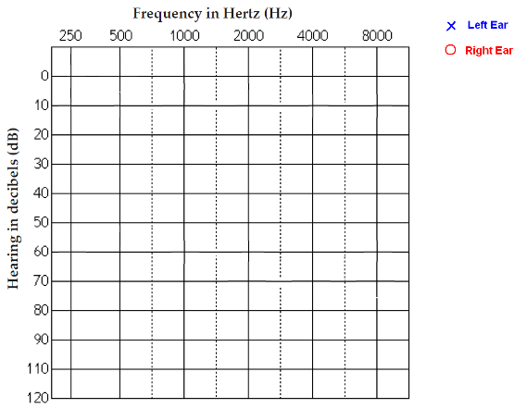

The Xs and Os are connected with lines to help keep track of the hearing levels across the different pitches. Hearing levels are often described in a progression of loss: normal hearing, mild hearing loss, moderate hearing loss, moderately severe hearing loss, severe hearing loss, and profound hearing loss. The following chart shows the ranges for each type of hearing level.

Normal Hearing | 0-20 dB
Mild Hearing Loss | 21-40 dB
Moderate Hearing Loss | 41-55 dB
Moderate to Severe Hearing Loss | 56-70 dB
Severe Hearing Loss | 71-90 dB
Profound Hearing Loss | >90 dB

The figures below show example audiograms for different levels of sensorineural hearing loss in both ears.
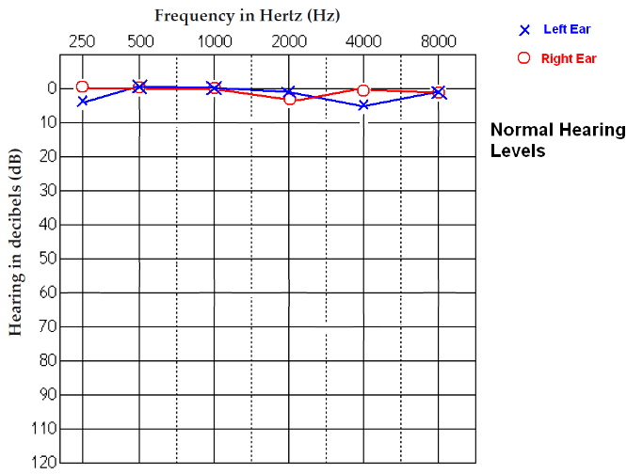
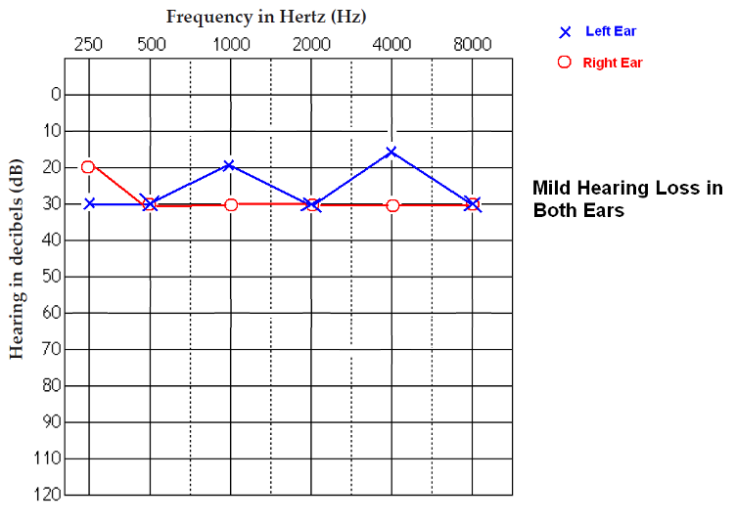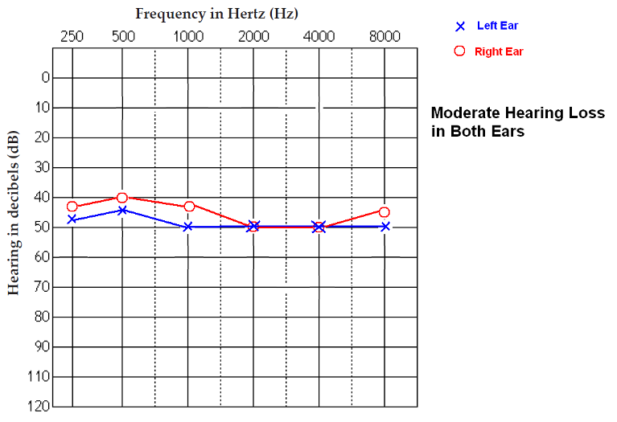
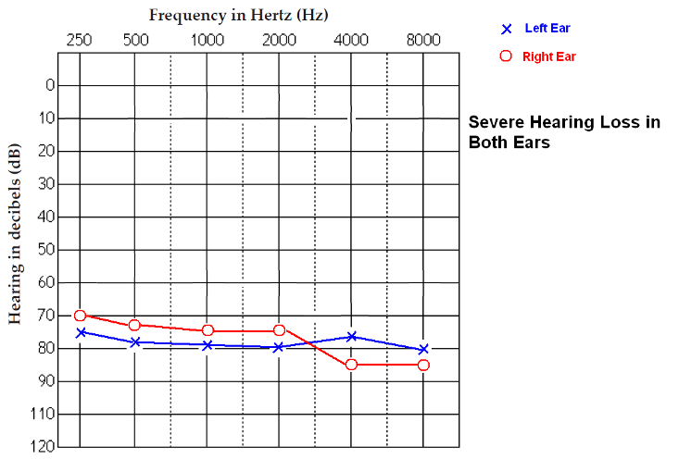
Conductive hearing loss can also be represented in an audiogram. The air conduction levels are represented as Xs and Os and the bone conduction levels are represented as < and >. Because conductive hearing loss is due to problems with the middle ear, hearing levels are better with bone conduction than with air conduction. Conductive hearing loss is therefore represented when bone conduction is at least 10 decibels better than air conduction. Below are two examples of audiograms. The audiogram on the left shows no hearing loss and the audiogram on the right shows conductive hearing loss.
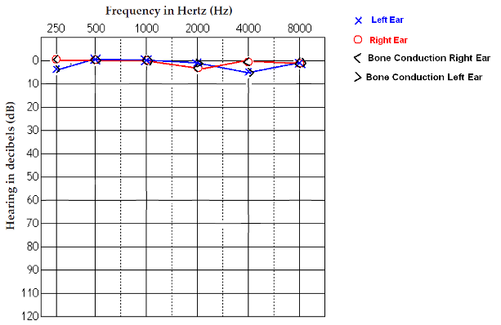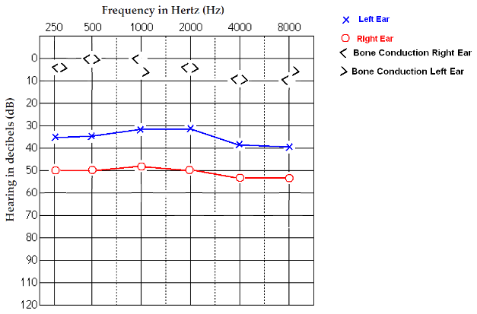

- Obtain an Activity 1.3.2: Student Resource Sheet from your teacher and take out your Activity 1.3.1: Student Resource Sheet.
- Match up each audiogram with the corresponding patient case study. Fill in the appropriate patient number next to each audiogram. Compare answers with a classmate.
- Answer Conclusion questions 2 – 3.
Can You Hear Me Now?
You will test your hearing and use Logger Pro to create an audiogram. Note that what you will be doing is similar to a Pure Tone Test because the program tests for the subject’s hearing threshold at different frequencies; however, due to the audio settings, this test should NOT be used for diagnostic purposes. Note that one partner will act as the test subject while the other partner acts as the test administrator. Once the test is completed, switch roles so that each partner completes the hearing test. Make sure that each partner uses his or her own set of headphones. If you need to share a pair of headphones with another student, make sure to put clean ear pads on the headphones.
- Turn the volume on the computer to the lowest setting.
- Start the Logger Pro program and open the PLTW folder. Open the Audiometric Test file from the Can Your Hear Me Now folder within the PLTW folder.
- From the Start menu on your computer, under All Programs, locate the Vernier Software folder and open the Signal Generator program.
- Note that the following pop-up box will open.
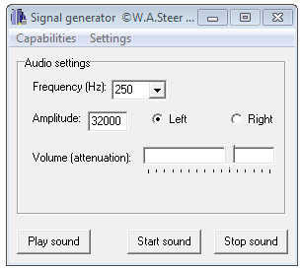
- Use your mouse to move the Volume (attenuation) button to the second dash from the left.
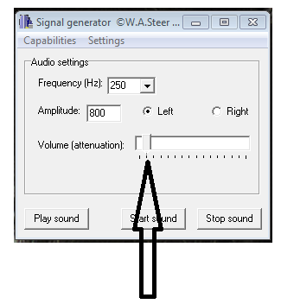
- Change the Frequency to 250 Hz, the Amplitude to 800, and click on the left ear.
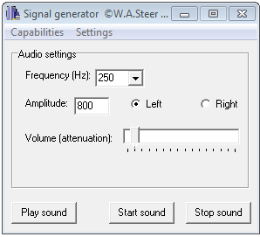
- Note that one partner will act as the test administrator while the other partner acts as the test subject. The test subject will face away from the test administrator while the test is being conducted and raise his or her hand when the tone is heard. The test administrator will follow steps 27 – 34 to perform the test.
- Open the volume control panel on your computer. Note that with most computers you can open the volume control panel by double-clicking the speaker icon .
- Click Start sound on the Signal generator program.
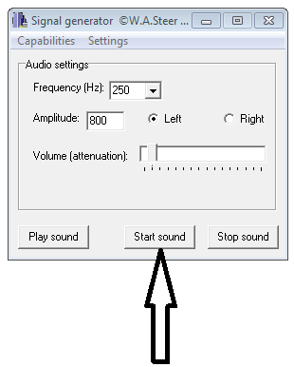
- Slowly increase the volume one decibel at a time, if possible, on your computer until the test subject first hears a tone. Remember that the test subject should raise his or her hand when the tone if first heard. This is the subject’s hearing threshold for this frequency.
- Note: If the subject hears the tones in the opposite ear than is indicated on the screen, the headphones are on backwards. Switch around the headphones and begin the test again.
- Determine how many decibels the hearing threshold is on the volume control panel. Note that the decibels will be displayed when you click on the volume control slider.
- If the decibels does not display when you click on the volume control slide, you will need to estimate the number of decibels. Note that the volume control panel slider has hash marks, each hash mark is approximately 10 decibels. Use the position of the slider to estimate the decibels based on the hash marks.

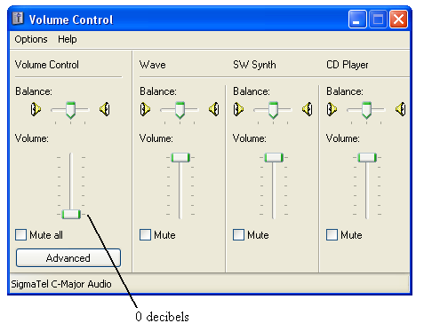
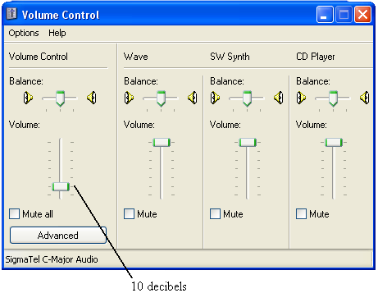
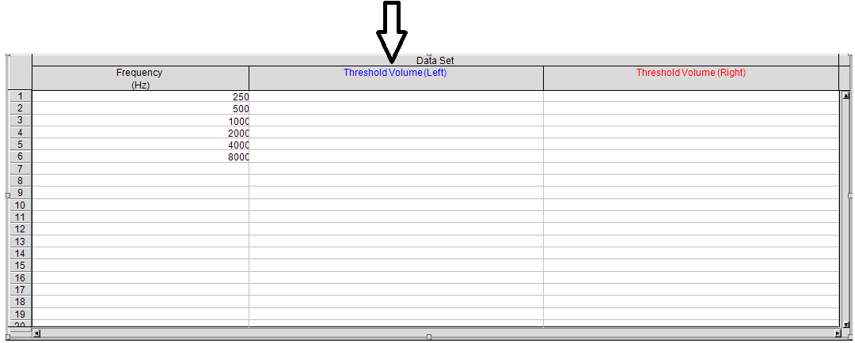
- Enter this threshold into the Data Set chart in Logger Pro for the left ear next to the 250 Hz frequency.

- Continue to find the test subject’s hearing threshold for the left ear at the following frequencies: 500 Hz, 1000 Hz, 2000 Hz, 4000 Hz, and 8000 Hz. Enter the data into Logger Pro.
- Repeat hearing test for the test subject’s right ear.
- Note that the software will automatically graph the data on the graph below the chart. Below is an example audiogram.
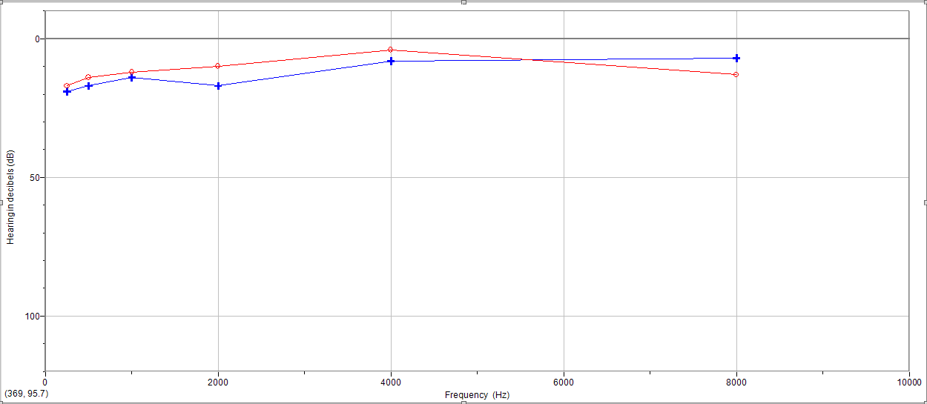
- Copy and paste the Audio Threshold graph into a blank Word document. Click or highlight the area to copy and select Copy from the file menu on the top of the screen or use Control C. Use the Paste command or Control V to place the graph into the blank Word document.
- Print this results page. Write Normal Hearing Test in your laboratory journal and attach the results below this title.
- Complete the hearing test a second time, but with cotton balls in the subject’s ears. This will simulate a mild hearing loss.
- Write Mild Hearing Loss in your laboratory journal and attach the results below this title.
- Answer Conclusion questions 4 - 5.
- Switch roles with your partner.
Audiology Careers
- Conduct a personal interview with either an audiologist or an otolaryngologist (also called an Ear, Nose, and Throat Physician). Ask at least five of the following interview questions as well as three additional questions you create:
- What are the duties and responsibilities of someone working in this occupation?
- What do you like about this occupation?
- What do you dislike about this occupation?
- What is your educational background?
- What is a typical day like for you?
- What is the salary range for someone in this occupation?
- What is your most satisfying experience so far?
- What advice do you have for someone considering this career field?
- Hand in a written or typed report of the interview to your teacher. Be sure to include the following in the written report: the person being interviewed, date of interview, the questions asked, and the responses given. Include a copy of the written report in your career journal.
- Answer Conclusion question 6.
Part II: Interventions for Hearing Loss
- Investigate the various types of medical interventions available for patients with hearing loss, including non-technology related interventions such as surgery and sign language. Use the following websites to begin your investigation. Take notes in your laboratory journal.
- American Speech-Language-Hearing Association – Assistive Technology http://www.asha.org/public/hearing/treatment/assist_tech.htm
- HearingCenterOnline.com – The Interactive Hearing Aid http://www.hearingcenteronline.com/howaid2.shtml
- Mayo Clinic – Hearing Aids
- http://www.mayoclinic.com/health/hearing-aids/HQ00812/UPDATEAPP=false&FLUSHCACHE=0
- National Institute on Deafness and Other Communication Disorders – Cochlear Implants http://www.nidcd.nih.gov/health/hearing/coch.asp
- eHealthMD.com – How is Hearing Loss Treated? http://www.ehealthmd.com/library/hearingloss/HL_treatment.html
- Work with your partner from Activity 1.3.1 to decide which type of intervention would be most appropriate for your assigned patient case study.
- Answer Conclusion question 7.
- As a class, discuss Sue Smith’s case. The group that was assigned to Sue Smith’s case should present their research findings with their class as well as their recommendation for an appropriate intervention for Sue.
- Decide as a class whether you agree with the recommendation, and decide what steps should be taken in Sue’s future to prevent further hearing damage.

Conclusion Questions
- Patients with Tinnitus experience the constant perception of sound in the ear, often in the form of high pitched whining, buzzing, hissing, ringing, or whooshing sounds. The Speech-in-Noise Test you just performed uses a constant whooshing sound to simulate environmental noise, but also can be used to simulate what it is like to live with Tinnitus. Explain how you felt while taking this test.

- Why would a person with conductive hearing loss hear the tuning fork through bone conduction longer than or equally as long as through air conduction?

- All sounds for speech vibrate at different frequencies, which is how you differentiate speech sounds. Vowels are relatively low in pitch, while consonants such as l, m, and n are in the middle range of pitches. Many speech sounds such as s and f are high in pitch. How would speech understanding be affected by a person with moderate to severe high frequency sensorineural hearing loss?

- How did your hearing compare with the cotton balls in your ear compared to your normal hearing without the cotton balls?

- What type of hearing loss does this simulate? Explain your answer.

- Would you be interested in pursuing a career as an audiologist or an otolaryngologist? Explain your reasoning.

- Which type of intervention do you think is most appropriate for your patient case study? Explain your reasoning.

Web Portfolio (at a minimum)
- Picture performing Rhinne test
- Picture wearing headphones
- Short summary of this Activity and what you have learned

