Activity 5.1.3: Isolating Bacteria

Introduction
As a medical detective, you have now identified that because Anna was treated with antibiotics, it means that she was diagnosed with a bacterial infection. In order to determine the exact species of bacteria, the next step is to culture or grow bacteria from Anna’s urine sample. Luckily, the laboratory that originally cultured Anna’s urine has preserved a sample that you can use for further tests. You will now play the role of a microbiologist specializing in diagnostic microbiology. A microbiologist is a scientist who investigates the growth, structure, development, and other characteristics of microorganisms, such as bacteria. Diagnostic microbiology is a specialty within microbiology concerned with the isolation and identification of bacteria in a specimen from a patient.

Specimens taken from a patient sample usually contain a mixture of different bacteria. Pure cultures, or samples with only one type of bacteria, are necessary to accurately study a bacterial species. Therefore it is necessary to isolate all of the possible pathogenic or disease causing organisms in order to study the sample by itself. Once you have isolated individual colonies, you can use these colonies for identification tests. Bacteria grow in groups called colonies, on a growth media called agar. A sample of the specimen is streaked onto an agar plate in order to physically separate the bacterial colonies. Whenever working with microorganisms, it is important to observe the rules of aseptic technique. Aseptic technique refers to a procedure performed under sterile conditions. Aseptic technique assures that contaminants are not introduced into a specimen and that infectious agents are not spread to you or laboratory surfaces. In this activity you will use aseptic technique to isolate bacterial colonies from four samples, including Anna’s, and then complete a gross examination of the colonies from Anna’s sample.
Equipment
- Computer
- Aseptic Technique Resource Sheet
- Activity 5.1.1 Medical History Resource Sheet
- Laboratory journal
- PBS Course File
- Career journal
- Alcohol lamp
- Matches
- Individually wrapped sterile inoculation loops (4)
- Agar Petri dishes (4)
- Samples of K. rhizophilia, K. roseus, S. aurantiaca, and ‘Anna’s Sample’
- Safety goggles
- Latex or Nitrile exam gloves
- Laboratory apron
- Disinfectant in squirt bottle
- Disinfectant in 500 mL beaker
- Permanent marker
- Tape
- Magnifying glass
- Colored pencils
- Ruler
Procedure
- Obtain and read through the Aseptic Technique Resource Sheet.
- Pay attention as your teacher demonstrates all of the procedures described in the resource sheet.
- Disinfect your work area and wash your hands.
- Put on the proper personal protective equipment.
- Work with a partner and obtain an alcohol lamp, matches, 4 agar Petri dishes, and 4 sterile plastic inoculation loops.
- On the outside edge of the top lid of the Petri dishes, write your group’s initials and date.
- Label the first plate K. rhizophilia, the second plate K. roseus, the third plate S. aurantiaca, and the fourth plate “Anna’s Sample.” Note that there are specific rules to name bacteria. Every bacteria consists of two names, the Genus and the species, and both names are always italicized. Many times the first named is abbreviated by its first letter and the second name is written out.
- Light the alcohol lamp. Make sure your hair and clothing are safely away from the flame.
- Follow your teacher’s directions for obtaining a sample of each of the four cultures and streak each culture onto the appropriate plate using the Aseptic Technique resource sheet as your guide.
- Seal the plates shut with tape. The plates should NOT be opened from now on.
- Place the plates upside down in the incubator at 37°C and allow the cultures to grow for 24 hours. Placing plates upside down ensures that condensation does not drip onto the cultures.
- Wash the area where you were working with a disinfectant as directed by your teacher.
- Place your gloves in the hazardous waste container.
- Disinfect your work area and wash your hands.
- After the samples are done incubating, put on the proper personal protective equipment.
- Draw four circles in your laboratory journal to represent the four plates, as shown below.
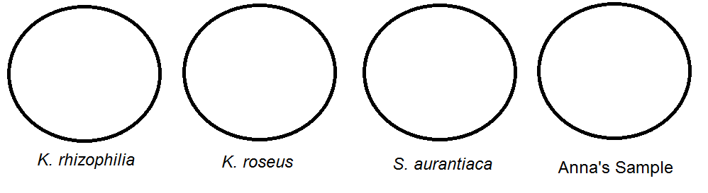
- Obtain your plates from the incubator. Do not open the plates.
- Check for any growth on the plates. Note any difference in growth rates or types of growth among the sections.
- Use a magnifying glass to look at the plates.
- Draw what you see using colored pencils on each plate.
- Refer to the Activity 5.1.1 Medical History Resource Sheet. Under the Tests Performed section, write “Gross Examination of Colony Morphology” in the second bullet and in the first blank under the Test Results section.
- Carefully examine the appearance of the isolated bacterial colonies on each plate.
- Use a ruler to determine whether the colonies are large (> 1 mm diameter) or small (< 0.5 mm diameter). If possible, complete this measurement without removing the lid of the petri dish. Record your observation in the Data Table 1 below.

Data Table 1
Species | Size | Margins | Elevation | Color
Unknown (Anna’s Sample)

K. rhizophilia

K. roseus

S. aurantiaca

- Determine the type of margins of the colonies (smooth or wavy). Do not remove the lid of the petri dish. Record your observation in Data Table 1.

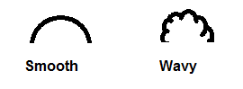
- Determine the elevation of the colonies (whether they are flat, convex, or raised). Do not remove the lid of the petri dish. Record your observation in Data Table 1.
- Determine the color of the colonies (red, gray, white, cream, or translucent). Do not remove the lid of the petri dish. Record your observation in Data Table 1.
- Match your observations with the culture key below to attempt to determine the species of bacteria on Anna’s plate. Remember that gross examination of an unknown bacteria is generally the first step performed in identification. While it is helpful in eliminating some possibilities, it is rarely sufficient alone due to the large amount of bacterial species and degree of variation between them.
Species | Size | Margins | Elevation | Color
Enterobacter aerogenes | Large | Smooth | Convex | Cream
Enterobacter cloacae | Small | Smooth | Convex | Cream
Eschericia coli | Small | Smooth | Convex | Translucent
Serratia liquefaciens | Small | Smooth | Convex | Cream
Serratia marcescens | Small | Wavy/Irregular | Raised | Red/Pink
Bacillus megaterium | Large | Smooth | Raised | Cream
Micrococcus luteus | Small | Smooth | Convex | Yellow

- Record your observations of Anna’s Sample under the Gross Examination of Colony Morphology section (under the Test Results section).
- Dispose of the plates as directed by your teacher. Do not place them in a trash can.
- Wash your work area with a disinfectant as directed by your teacher.
- Place your gloves in the hazardous waste container.
- Wash your hands.
- Note that you have now isolated bacterial colonies from Anna’s sample. Use the Internet and appropriate websites to determine what the next steps of the investigation should be in order to determine the exact bacterial strain responsible for making Anna sick. Record your notes in your laboratory journal.
- File the Aseptic Technique Resource Sheet in the appropriate tab of your course file. Use the PBS Course File – Table of Contents as a guide.
- Answer the Conclusion questions.
Conclusion
- What is the purpose of aseptic technique?

- Why do microbiologists need to isolate bacterial colonies from a specimen?

- Are there multiple types of bacterial colonies in Anna’s sample? Yes or no. Explain your reasoning.

- What is your preliminary idea of the species of bacteria responsible for Anna’s infection? Explain your reasoning.

- What are the possible next steps of the investigation to determine the exact bacterial strain responsible for making Anna sick?

