Trivia Questions to be used for Bonus Points
- How much did Albert Einstein's brain weigh?
  - 2.71 lbs., significantly less than the average human brain, but he had many more
glial cells than average

- How many thoughts does the average person have per day?
  - 70,000

- Who discovered the 1st neurotransmitters?
  - Otto Loewi

- What animal’s heart did Otto Loewi use to discover neurotransmitters?
  - Frog

- How many NA+ get transported through the pump?
  - 3
- What do neuorotransmitters cross to be accepted by the next neuron?
  - Synapse

- Which holiday was the day in which Otto Loewi first thought of the frog experiment in which he demonstrated the chemical transmission of a nervous impulse?
  - Easter

- What does MV stand for?
  - Millivolts

- What is another word for nerve cells?
  - Neurons

- Composed of many tubules, name the structure of a neuron that receives signals from other cells.
  - Dendrite(s)

- Noradrenaline, GABA, and Dopamine are examples of these chemicals responsible for sending a signal to another neuron. Name the collective name for these chemicals that are receiver by receptors
  - Neurotransmitter(s)

- What is the name for the step where the potassium stays in the cytoplasm, and where all the sodium flows into the cytoplasm through potassium channels?
  - Depolarization

- What is the name for the step where the potassium leaves the inside of the cells and makes the outside have a positive charge and the inside a negative charge? (Returning of cell to resting potential)
  - Repolarization

Action Potential
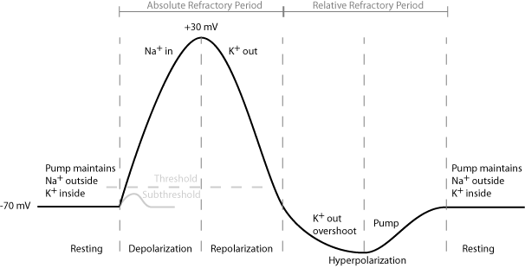
a. In response to the appropriate stimulus, the cell membrane of a nerve cell goes through a sequence of depolarization from its resting state (, a nominal rest potential of -70 mV) followed by repolarization to hyperpolarization, then back to resting potential.
The repolarization typically overshoots the resting potential to about -90 mV. This is called hyperpolarization and is actually very important. Hyperpolarization ( Relative Refractory Period) raises the threshold for any new stimulus. Part of the importance of hyperpolarization is in preventing any stimulus already sent up an axon from triggering another action potential. In other words, hyperpolarization assures that the signal is proceeding in one direction. The absolute Refractory period prevents the neuron from receiving another stimulus during this time (all or none theory),

Sodium Potassium Pump
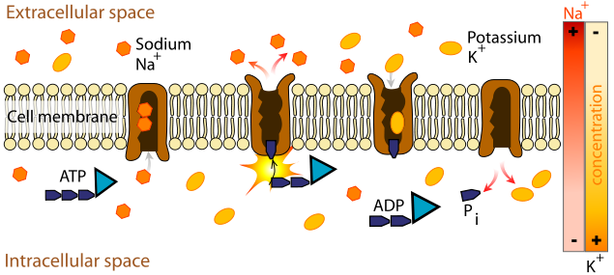

Understand these Terms and all vocabulary words
Brain Stem-The part of the brain composed of the midbrain, pons, and medulla oblongata and connecting the spinal cord with the forebrain and cerebrum.
Central nervous system- The part of the nervous system which in vertebrates consists of the brain and spinal cord, to which sensory impulses are transmitted and from which motor impulses pass out, and which supervises and coordinates the activity of the entire nervous system
Cerebellum A large dorsally projecting part of the brain concerned especially with the coordination of muscles and the maintenance of bodily equilibrium, situated between the brain stem and the back of the cerebrum and formed in humans of two lateral lobes and a median lobe.
Cerebrum- The dorsal portion, composed of right and left hemispheres, of the vertebrate forebrain; the integrating center for memory, learning, emotions, and other highly complex function of the central nervous system.
Gyrus-A convoluted ridge between anatomical grooves.
Limbic System- A group of subcortical structures (as the hypothalamus, the hippocampus, and the amygdala) of the brain that are concerned especially with emotion and motivation.
Lobe- A division of a body organ (as the brain, lungs, or liver) marked off by a fissure on the surface.
Peripheral nervous system- The part of the nervous system that is outside the central nervous system and comprises the cranial nerves excepting the optic nerve, the spinal nerves, and the autonomic nervous system.
Phrenology- The study of the conformation of the skull based on the belief that it is indicative of mental faculties and character.
Sulcus- A shallow furrow on the surface of the brain separating adjacent gyri.
Action Potential- A momentary reversal in electrical potential across a plasma membrane (as of a nerve cell or muscle fiber) that occurs when a cell has been activated by a stimulus.
Axon- A long nerve cell process that usually conducts impulses away from the cell body.
Dendrite- Any of the usually branching protoplasmic processes that conduct impulses toward the body of a neuron.
Ion- An atom or group of atoms that carries a positive or negative electric charge as a result of having lost or gained one or more electrons.
Myelin sheath- In a neuron, an insulating coat of cell membrane from Schwann cells that is interrupted by nodes of Ranvier.
Neurologist- A physician skilled in the diagnosis and treatment of disease of the nervous system.
Neuron- A nerve cell; the fundamental unit of the nervous system, having structure and properties that allow it to conduct signals by taking advantage of the electrical charge across its cell membrane.
Neurotransmitter- A substance (as norepinephrine or acetylcholine) that transmits nerve impulses across a synapse.
Reaction Time- The time elapsing between the beginning of the application of a stimulus and the beginning of an organism's reaction to it.
Reflex- An automatic and often inborn response to a stimulus that involves a nerve impulse passing inward from a receptor to the spinal cord and thence outward to an effector (as a muscle or gland) without reaching the level of consciousness and often without passing to the brain.
Synapse- The place at which a nervous impulse passes from one neuron to another.
Glial cells - provide support and nutrition, maintain homeostasis, form myelin, and facilitate signal transmission in the nervous system

Know/ be able to label the areas of the brain and know where the below actions or functions happen.
Balance Hearing Smell
Vision Coordination Movement
Speech Reasoning Happiness
Arousal blood pressure Thirst and Hunger
Pain Breathing Taste

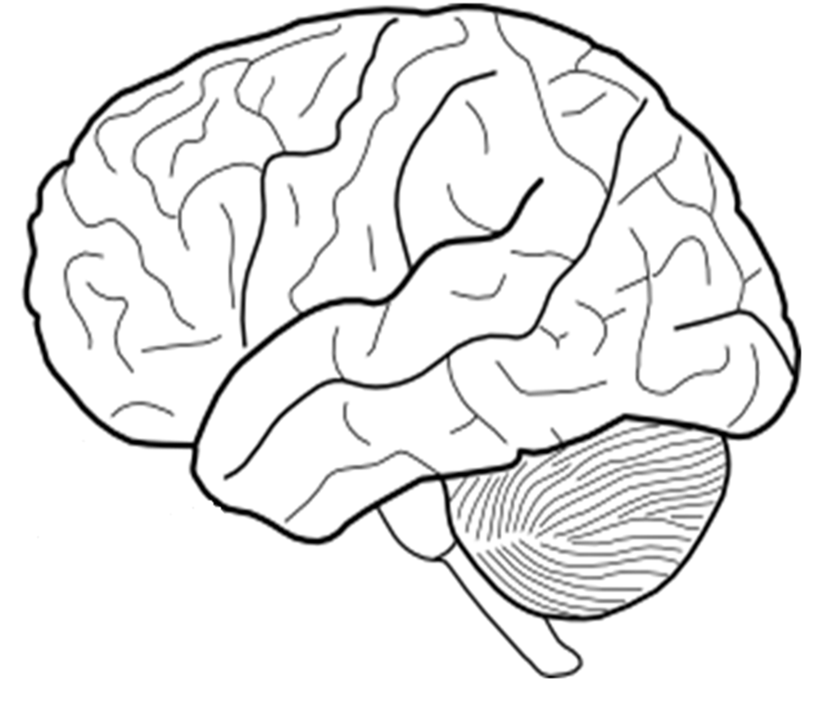

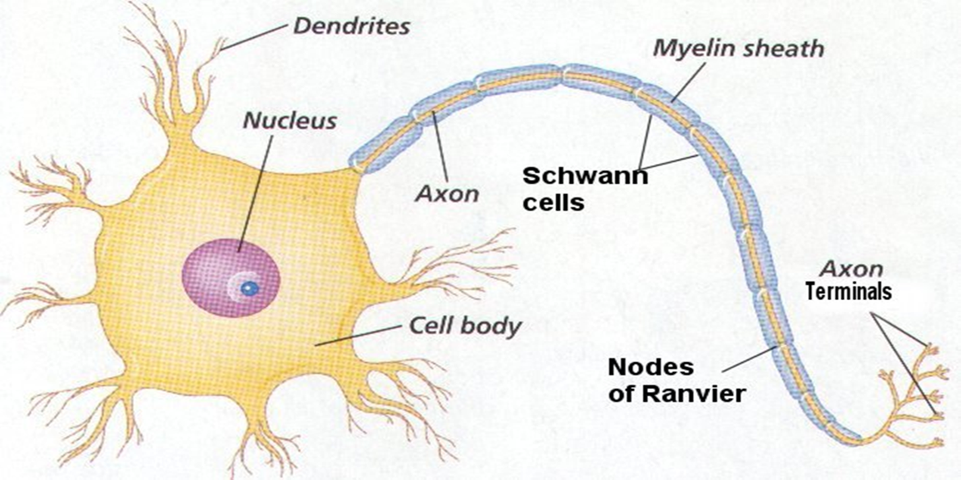
Know/ be able to label the areas of the neuron:
Synapse Cell body Schwann Cell
Myelin Sheath Nucleus Neurotransmitters
Axon terminals Node of Ranvier
Axon Dendrites
Neurological Disorders
Multiple Sclerosis
MS causes progressive destruction of the myelin sheaths of neurons in the CNS. This destruction slows and then short-circuits conduction of nerve impulses.

Alzheimer’s disease
In Alzheimer’s patients there is a loss of neurons that liberate acetylcholine, a key neurotransmitter. It is also hypothesized that beta amyloid plaques can form on the outside of neurons and interfere with cellular communication. Microtubules may also become tangled and alter the cell’s ability to transport materials, ultimately affecting communication.

Epilepsy
Epileptic seizures are initiated by abnormal electrical discharges from neurons in the brain. Too many neurons are firing at one time. The nature of the seizure is defined by the region of the brain that is affected. If the motor cortex is affected, involuntary contractions of the muscles will result. If the limbic system or the frontal lobes are affected, loss of consciousness may occur.

Parkinson’s disease
The symptoms of Parkinson’s disease are related to the loss of dopamine secreting cells in the substantia nigra (midbrain). Dopamine signals allow for coordinated movement. Dopamine mediated pathways are inhibited, and create the variety of symptoms seen in PD patients, including movement problems and abnormal emotional response.

ALS (Lou Gerhig’s disease)
ALS is a disease of the motor neurons, hence the reason why a patient with ALS can be severely limited in movement and the ability to control muscles for breathing and speaking, but remains cognitively untouched. When the motor neurons die, the ability of the brain to control muscle movements is severely impaired. Motor neurons can no longer send signals to the muscles and the muscles begin to atrophy.

Huntington’s disease
Huntington’s disease results from genetically programmed damage to neurons in particular areas of the brain (hence the variety of symptoms). As specific nerve cells waste away, function declines tremendously. Huntington’s is unique in that it is a autosomal dominant disease, meaning that if a parent has Huntington’s disease, there is a 50% chance that his/her child would also have the disease.

Essential Questions
- How do the central nervous system and the peripheral nervous system work together to control the body?

- What are the functions of the main regions of the brain?

- How do neurons convey information using both electrical and chemical signals?

- How do the different types of neurons work together to send and receive signals?

- What is the basic structure and function of a neuron?

- How do the different types of neurons work together to send and receive signals?

****Study the PowerPoint on the Weebly****

