## RECIPes

Ants on a Log

-Low-fat peanut butter, Celery, Raisins

1. Spread peanut butter on celery
2. Sprinkle raisins on peanut butter
3. Enjoy!

Fruit Kabobs

-Fruits of your choosing, skewers

1. Cut the fruit into slices
2. Slide the slices onto skewers
3. Eat it!

Skinny Nutella

-1 cup hazelnuts, 3/4 cup chocolate chips, 3/4 cup lite coconut milk (almond or regular milk will work), 1 1/2 tablespoons mild honey, and a pinch of sea salt

1. Preheat oven to 350 degrees.
2. Evenly spread hazelnuts on a cookie sheet and roast approximately 15 minutes.
3. Remove and allow to cool at room temperature.
4. Remove skins by placing hazelnuts in a kitchen towel and rubbing until the skins fall off.
5. In a medium saucepan, add chocolate chips, milk, honey and salt, turn to low heat and heat until chips are completely melted.
6. Remove from heat and allow to cool slightly while preparing hazelnuts.
7. Add hazelnuts to a food processor and pulse until you have a butter like consistency.
8. Add chocolate mixture to food processor and pulse until well combined with hazelnut butter.
9. Eat and enjoy!

[](http://www.google.com/url?sa=i&rct=j&q=super+heroes&source=images&cd=&cad=rja&docid=TMz7rOyb2J-CZM&tbnid=gUks43Hu38wCiM:&ved=0CAUQjRw&url=http://www.recruiterchicks.com/tag/superheroes/&ei=G5IjUf2vAsHk2AW5iIHwDA&bvm=bv.42553238,d.aWM&psig=AFQjCNFxERcKYMmkFDW0kORXWT5PoHSI6g&ust=1361372056055227)

Fighting the Super-villain of Childhood Obesity



# herOes

Date of publication

How to Be a Hero

There are tons of ways you and your family can be healthy heroes.

* Go outside and run, jump, and fight super villains. Maybe your parents can dress up and join you!
* Just have fun with it!
* Another thing you can do is eat tons of fruits and veggies. This will make you grow super strong and fast.
* Don’t know what to make? Look on the back for some easy-peasy recipes! Woohoo!
* Don’t eat like a villain at school…make super choices!

The Villain of Obesity

* Obesity is having too much body fat.
* Obesity has doubled in the past thirty years.
* If you’re not careful, obesity can cause heart problems
* Having healthy parents can help defeat obesity in kids.



http://joannameriwether.com

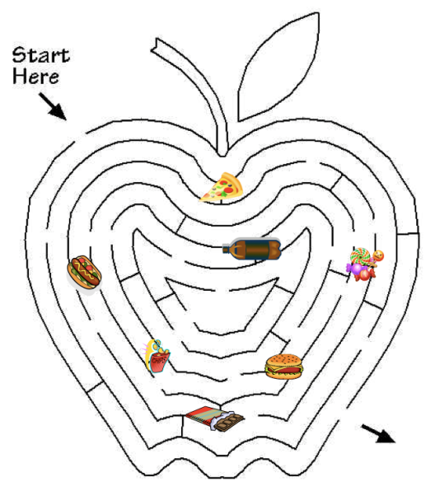

Food Maze!

bestclipartblog.com



Company Name

Street Address

Address 2

City, ST ZIP Code

Phone (555)555-0125

Fax (555)555-0145

Web site address