The Facts
Here are some facts about obesity:
- 29% of people in Daviess County in are inactive.
- 24% of Daviess County residents are obese.
- Only 15.9% of people eat the right amount of fruits and vegetables.

Healthy and tasty snacks
- Fruit

Be A Hero. eat healthy and exercise.

- Vegetables

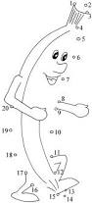
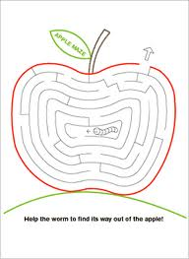

Performed by the Life Science Academy

herOes

Date of publication

Funny jokes!
- How do you make an artichoke?
Strangle It
- Why did the grape stop in the middle in the road?
He ran out of juice

Our skits
- Heroes:
  - Eat Healthy
  - Exercise
- Villians:
  - Eat Unhealthy
  - Are Lazy.
Some of our heroes include Batman, Spiderman, and the Incredible Hulk.
Some of our villains include Venom and Catwoman

Fun ways you can exercise
- Playing sports

- Playing tag

- dancing

Our SOurces
- Kentucky Health Facts. (2008). Location: Daviess County. [accessed 26 February 2013]. Retrieved from http://www.kentuckyhealthfacts.org/data/location/show.aspx?cat=1%2C2%2C3%2C5%2C8%2C11&loc=30
- Mayo Clinic. (2013). Exercise: 7 Benefits of Regular Physical Activity. [accessed 3 March 2013]. Retrieved from http://www.mayoclinic.com/health/exercise/HQ01676
- Prongo.com.Jokes(2012) [accessed March 10 2013] retriebed from http://www.prongo.com/jokes/index.asp
Company Name
Street Address
Address 2
City, ST ZIP Code
Phone (555)555-0125
Fax (555)555-0145
Web site address

