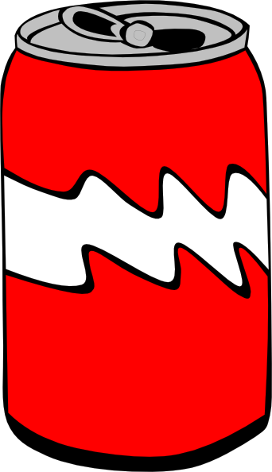
Test
- How many hours of sleep should you have?
  - 8 hours
  - 11 hours
  - 7 hours
  - 10 hours
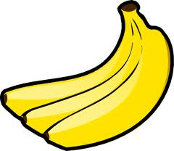
- Which is healthier?
  - Soda
  - Candy bar
  - Bananas
  - Fruit Roll-ups

- Which is the healthier exercise choice?
  - Watching television for more than two hours a day
  - Laying in bed all day
  - Exercising for at least 30 minutes a day
  - Playing video games

- How many fruit servings should you have a day?
  - 5 servings
  - 2 servings
  - 10 servings
  - 1 servings

