**Pre and Post Test Questions:**

1. **Which activity would you rather do?**

**a. b.**

1. **Which food do you like best?**

**a. b.**

1. 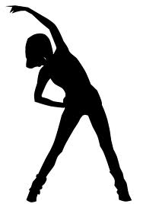**Which is better?**

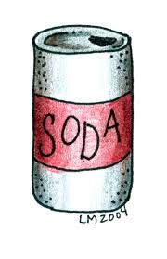**a. b.**

1. **True or False: You should exercise for 15 minutes every day.**
   1. **True**
   2. **False**