Aseptic Technique Resource Sheet

Aseptic technique must be used whenever working with microorganisms such as bacteria. Aseptic technique assures that contaminants are not introduced into a specimen and that infectious agents are not spread to you or laboratory surfaces.

General Rules:
- New sterile inoculating loops must be used at all times to make transfers of bacterial cultures. If using metal inoculating loops, the inoculating loops need to be sterilized before and after each use, using the proper technique to flame the loop.
- Caps of test tubes or tops of Petri dishes must be held during the entire procedure and never placed on the desktop or contamination will result.
- Proper personal protective equipment needs to be worn at all times.
- Absolutely no food or drink is allowed in the laboratory area.
- Hair must be properly tied back.
- Inoculating loops should never be placed back into a sample, as this will contaminate the sample.
- All work surfaces need to be thoroughly disinfected before and after the lab using a disinfectant such as 10% Lysol, 70% alcohol, or household bleach.
- Hands must be thoroughly washed with soap and water before and after working with any samples.

Streaking a Plate:
The goal of this procedure is obtaining isolated bacterial colonies so you can analyze them and work with them if need be. This process is basically a dilution process. Each quadrant should contain less bacteria, leading to isolated colony growth.

Step One:
- Use a permanent marker to draw a “T” on the back of an agar plate, dividing it into three sections. Do not open the agar plate.
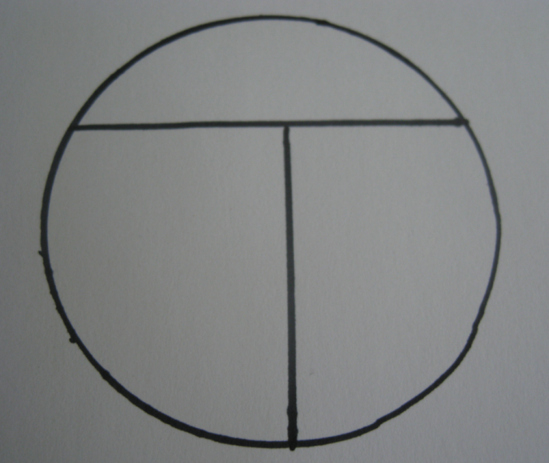

Step Two:
- Obtain a new plastic sterile inoculating loop or sterilize a metal inoculating loop. (Note that directions for how to sterilize a metal inoculating loop are found in the following section.)
- Obtain a single colony with the looped end of the sterile inoculating loop, either from a plate or from broth.
- Turn the plate so that the top of the “T” is near the palm of your non-dominant hand.
- Crack the lid of the plate by lifting it with your thumb and index finger.
- Gently touch the inoculating loop to the edge of the plate above the top of the “T.” Move the loop back and forth across the agar surface to spread out the sample of bacteria, creating a series of parallel lines at the top of the plate, as shown below. Make sure to gently slide the loop along the surface of the agar, being careful not to puncture the surface.
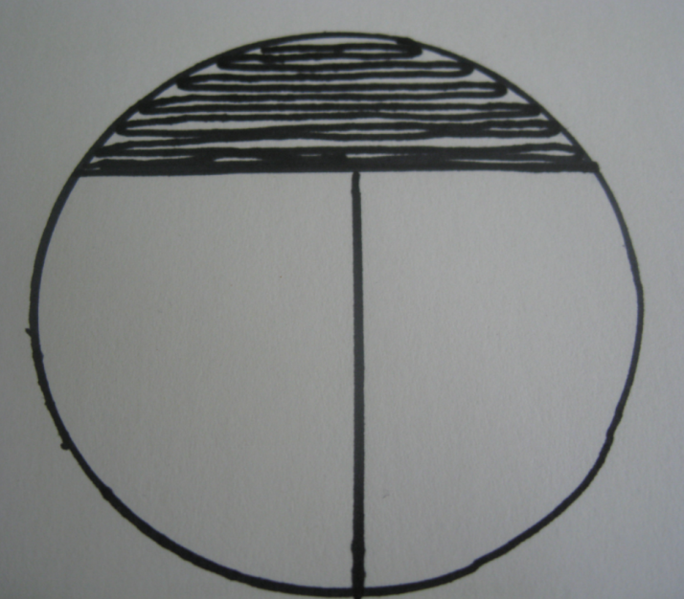

Step Three:
- Turn the plate 90° counter-clockwise.
- Using a sterile inoculating loop, repeat the streaking procedure in the section that is now the top. Cross into the section you just streaked once or twice and then drag the loop back and forth across the top section without going back to the section that you first streaked, as shown below.
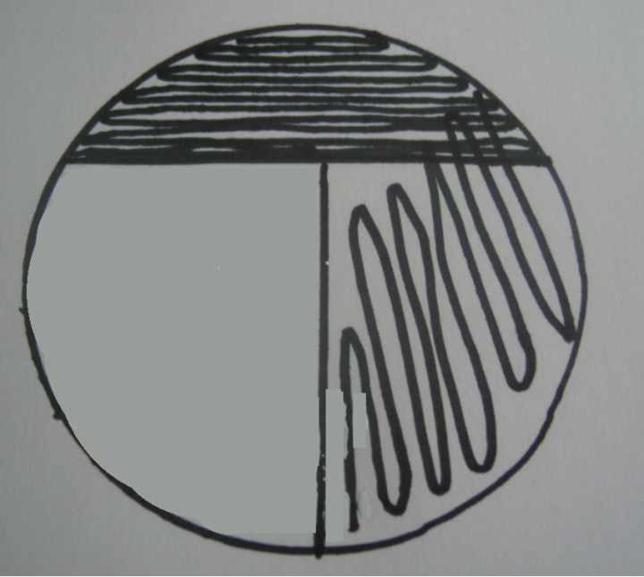

Step Four:
- Turn the plate 90° counter-clockwise.
- Using a sterile inoculating loop, repeat the streaking procedure in the last section of the plate. Again, cross into the section you just streaked two or three times and then drag the loop back and forth across the top section without going back to the sections previously streaked. Do NOT cross the material streaked in the first section. Remember that the goal of this procedure is to obtain isolated colonies. Therefore crossing into the section concentrated with lots of bacteria would defeat the purpose.
- Close the lid of the plate and label with your name and the date.
- Place the plate in the incubator upside down.
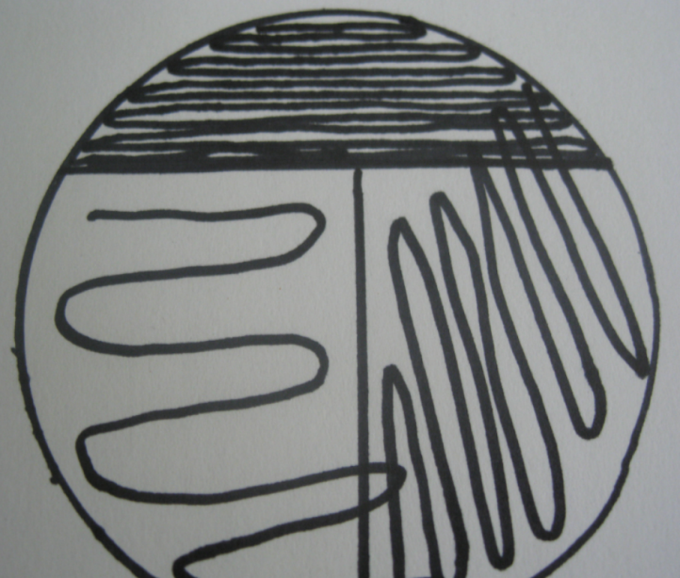

Bacterial Transfer from Broth:
The two common media used to grow bacteria are a clear soup-like nutrient broth, usually in tubes, and agar in a petri dish, also known as a plate. Whenever working with bacteria, it is necessary to obtain a culture either from broth or from a plate.
- Pick up a sterile inoculating loop in your dominant hand. If using a metal inoculating loop, sterilize it using a flame.
- Pick up the test tube in your non-dominant hand. Use the little finger of your dominant hand (the one holding the loop) to remove the cap from the test tube. Do not set the cap down.
- Flame the mouth of the test tube by passing it two or three times through the burner flame. Hold the tube almost parallel to the table top if it contains a broth. This will reduce the possibility of air-borne contaminants.
- Insert the loop into the tube and pick up a loop of culture.
- Remove the loop and carefully replace the cap on the tube. You now have a sample of culture on the inoculating loop that you can see as liquid in the loop. This sample can be used to streak a plate or can be transferred to new broth.
- Flame the mouth of the tube and cap it.
- If using a metal inoculating loop, make sure to flame the loop once you are done using it.

Bacterial Transfer from a Plate
- Pick up a sterile inoculating loop in your dominant hand. If using a metal inoculating loop, sterilize it using a flame.
- Pick up the plate in your non-dominant hand. Open the lid of the plate at a 45° angle. Do not remove the lid entirely.
- Obtain one colony from the plate with the inoculating loop. Be careful not to puncture the agar or touch any surrounding colonies.
- Carefully replace the lid on the plate. You now have a sample of culture on the inoculating loop that you should be able to see with your naked eye. This can be used to streak a plate or can be transferred to new broth.
- Flame the mouth of the tube and cap it.
- If using a metal inoculating loop, make sure to flame the loop once you are done using it.

Sterilizing a Metal Inoculating Loop
The goal of this procedure is to sterilize the inoculating loop whenever working with a sample.
- Hold the loop at a fairly steep angle so that the tip of the loop is in the hottest part of the flame. Hold the loop in the flame for a few seconds until it is red hot.
- Allow the loop to cool for a few seconds before use.
- Note: Whenever using metal inoculating loops, it is essential to flame and cool the metal loop after every use. It is very important to let the loop cool before inserting it into broth or near a colony, as excessive heat will kill the organisms.
