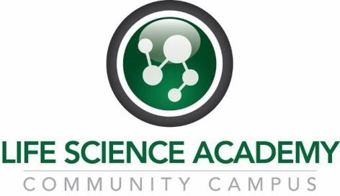
Senior Trip to the CDC
Permission Form

I give my LSA student ________________________________________________ permission to attend to LSA Senior Trip to the CDC in Atlanta, Georgia, March 22nd-24th. I understand students are responsible for paying for their own meals. I also understand my student needs to pay the $40.00 entrance fee to the Georgia Aquarium. I understand that dress for the CDC museum is business casual.
The total estimated cost including meals with aquarium ticket purchase = $150.00.
For the aquarium, my student will bring the $40.00 in ___CASH or has access to a personal credit or debit card _____ (initial)
I have made a note of the attached itinerary and contact numbers. _____ (initial)

___________________________________________ (signature) ____________ (date)

Schedule (subject to change)
- Wednesday 3/22
  - 7:00 AM CST: Leave DCPS
  - 5:00 PM EST: Arrive at Emory Conference Center
  - 6:00 PM: Shopping and dinner @ Emory Point
  - 9:00 PM: Arrive back at Emory Conference Center
- Thursday 3/23
  - 8:00 AM: Breakfast at Emory Conference Center & Hotel
  - 9:00 AM: Depart Emory Conference Center & Hotel
  - 9:30 AM: Special Tour of the CDC Museum
  - 12:00 PM: Lunch @ Emory Point
  - 2:00 PM: Arrive at Georgia Aquarium
  - 6:00 PM: Arrive back at Emory Conference Center & Hotel
  - 6:30 PM: Dinner at Emory Conference Center & Hotel
  - 8:00 PM: Depart Emory Conference Center & Hotel
  - 8:30 PM: Arrive at Fernbank Science Center & Observatory (9-10:30)
  - 10:00 PM: Arrive back at Emory Conference Center & Hotel
- Friday 3/24
  - 7:30 AM: Breakfast at Emory Conference Center & Hotel
  - 8:30 AM: Meeting with Eric Rogier, PhD, Microbiologist with the CDC, Malaria Branch
  - 10:00 AM: Depart Emory Conference Center
4:00 PM CST: Arrive DCHS

Contact Information
- Emory Conference Center : 1615 Clifton Road NE, Atlanta, Georgia 30329, Main: 404-712-6000, Toll Free: 1-800-933-6679
- Fernbank Science Center & Observatory: 156 Heaton Park Dr., Atlanta, GA 30307, Phone: 678-874-7102
- CDC Museum: 1600 Clifton Road Atlanta, GA 30329-4027 USA , 800-CDC-INFO (800-232-4636)
- Georgia Aquarium: 225 Baker Street NW, Atlanta, GA 30313, 404.581.4000

Additional Info Online
http://www.lifescienceacademy.net/cdc-senior-trip

