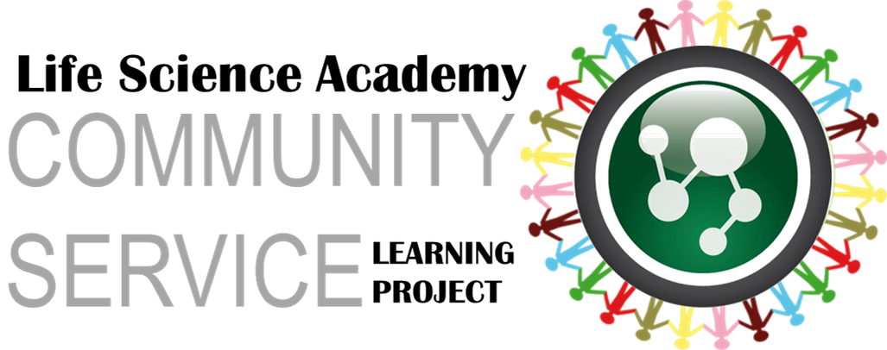

Dear Friend,

Help me Spread the Word to End the Word™. I invite you to be a fan of respect and join me in an on-going campaign to stop the use of the R-word and pledge #Respect for everyone. Over 500,000 people have pledged their support online since the campaign launched in 2009 and we hope you can join us by making your pledge to end the use of the R-word.

Visit http://www.lifescienceacademy.net/no-r-word-pledge and take the pledge and pass this email along to all your friends so together we can create communities of acceptance and inclusion for people with intellectual and developmental disabilities.

Thanks,
[NAME]

