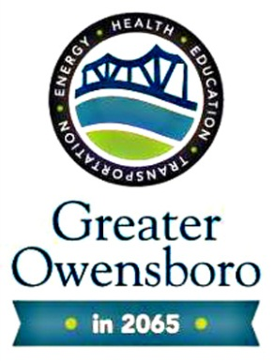
VISION 2065 HEALTH GROUP
Session Six

Ideation/Brainstorming

Part Two

Physical, Mental, Social Well Being

February 4, 2015th
11:30 a.m.-1:00 p.m.
Café A

Meeting Notes

- During this meeting we welcomed students from the Life Sciences Academy to our group.
- An overview of the journey was provided to the group.
- The group discussed the WHO definitions of health.
- The group broke into three groups based on survey input: Physical, Mental, and Social Well Being.
- With their respective groups, the teams performed to table top exercises.
- Look at the previous big ideas regarding health and working to categorize them into the most appropriate sub-category (Physical, Mental, Social Well Being)
- Working within group, brainstorm on those new and additional ideas within each subcategory (Physical, Mental, Social Well Being)

Next Steps
- Research and provide the group with a more detailed definition of health within the three subcategories.
- Inquire of GOEDC an example of the expected “putting it all together” document or event.
- Research and provide a sample of a visioning document that may be helpful if developing the final report out for the Vision 2065 Health group.
- Compile the information from the table top exercises for consideration at the Session Seven meeting on March 4th.

New and Existing Ideation Items to Physical, Mental, Social Well Being
(From Table Top 1 and 2 Exercises)

Physical Well Being
(Table Top 1: Previously developed ideas)
- Complete eradication of hunger
- Model community for health policy
- Total culture of wellness
- Overall needs being met
- Lowest rate of various health disease incidents in state
- Preventative research
- Efficient care for the vulnerable
- Community of health culture
- Identification of food borne illness/diseases
(Table Top 2: New ideas)
- Sustained self-mobility through aging by way of medical advancement, greater access and technological improvements
- 100% Smoke free environment
  - All forms of smoking
- Community walks
  - Community gardens
- Openly discuss individual health with one another in conversation
- Schools, churches, workplaces to be consistent on physical well-being
- Eliminate or replace products used to create addictive drugs

Mental
(Table Top 1: Previously developed ideas)
- Not yet completed
(Table Top 2: New ideas)
- Education
- Increasing positive thinking
- Security
- Mental health assessments
- Easy access to services
- Intergenerational community
- Management classes for mental well-being
- Create environment without walls
- Prevention

Social Well-Being
(Table Top 1: Previously developed ideas)
- Complete eradication of hunger
- Model community for health policy
- Total culture of wellness
- No reliance on cars
- Most efficient and effective access to education
- Leading research within the community
- Community of health culture
- Vibrant agricultural aspect of the community/Building a sustainable community
- Identification of food borne illness/diseases

(Table Top 2: New ideas)
- All inclusive planning and decision making process
- Culturally aware policy makers
- Diversity-Melting Pot Community
  - Cultural Inclusion
- Focus on empowerment and building leadership
- Focus on interpersonal relationships (social support)
- Eliminate Silo’s cross community connections
- Eliminate rural/urban divide – non departmentalized
- Open to outside people and ideas
- Centralized media attention

