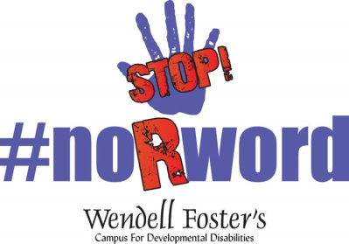
Individual Campaign
Planning Sheet

I will reach out to _______________ individuals.
I will get _______________ individuals to sign the pledge.
I will get _______________ individuals to buy a $15 t-shirt.

To reach out at my high school I will be working with
____________________________________________________________________________________________________________________________________________________________
You MUST list the way you reached out and number you connected with on our Impact Forum.

We will speak to (list organizations)
- __________________________________________________
- __________________________________________________
- __________________________________________________
- __________________________________________________

Our plan is to:

