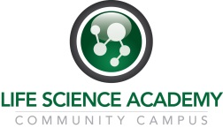
PBS Concept Map Rubric: 25 points possible, 5 points for each section

Component | 0-2 Point | 2-3 Points | 4-5 Points
Key Terms | <50% of key terms appear and are used correctly | 75% of key terms appear and are used correctly | 100% of key terms appear and have been used correctly.
Connectors | <50% of key terms are connected appropriately; many are missing or not used effectively. | 75% of key terms are connected appropriately | Key terms are all connected appropriately
Organization | Maps do not read smoothly  Does not read from general to more specific all the time  A clear understanding of the relationship between terms is not evident | Map reads smoothly and logically most of the time  Some understanding of the relationships between terms is shown | Map reads smoothly and logically in all places  The map shows a clear understanding of the relationships between terms.
Images | There are <3 images and they do not relate to topic | There are 3 images and they do relate to topic | There are >3 images of high quality, that relate and are used creatively
Word Choice | Too wordy/cluttered  More like paragraphs of text | Key points in some areas but too wordy in others | Simple, proper word choice  Key points outlined well

