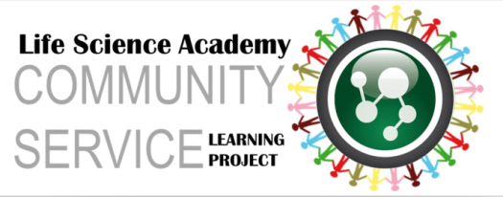
LSA Project Summary Rubric: 50 points possible
Criteria | Full Points
Goal & Objectives  (5 points) | Goal: A broad statement of what you wish to accomplish (general, intangible, and abstract). Describes your final impact or outcome and is linked to either an identified health need.  Objectives: Help you reach your goal and are SMART (Specific, Measurable, Attainable, Realistic and Time-Bound).
Impetus  (10 points) | Includes multiple pieces of evidence that show you are meeting a health need. All evidence is properly cited in-text and at the end of your summary.
Project Description (15 points) | Is well though out and thorough. No “big questions” remain after reading. Provides a detailed description of every aspect of your project.
Target Audience  (5 points) | Identifies your audience as captive or gathered and includes a plan to get permission for use of a captive audience –OR- an advertising/marketing campaign to capture your audience from the general community. The plan is detailed and realistic.
Line-Item Budget  (5 points) | Uses the excel file as provided and is under the $1,000 limit. Lower is better; the higher your budget the bigger the impact & justification should be. Uses available items when applicable and demonstrates frugality. No “big-ticket” items are left out and the budget shows careful consideration of all project needs.
Implementation  (10 points) | Shows critical thinking regarding the likely difficulties you will face in implementing your project –AND- a well though-out plan for how you will overcome each obstacle.

